User Experience 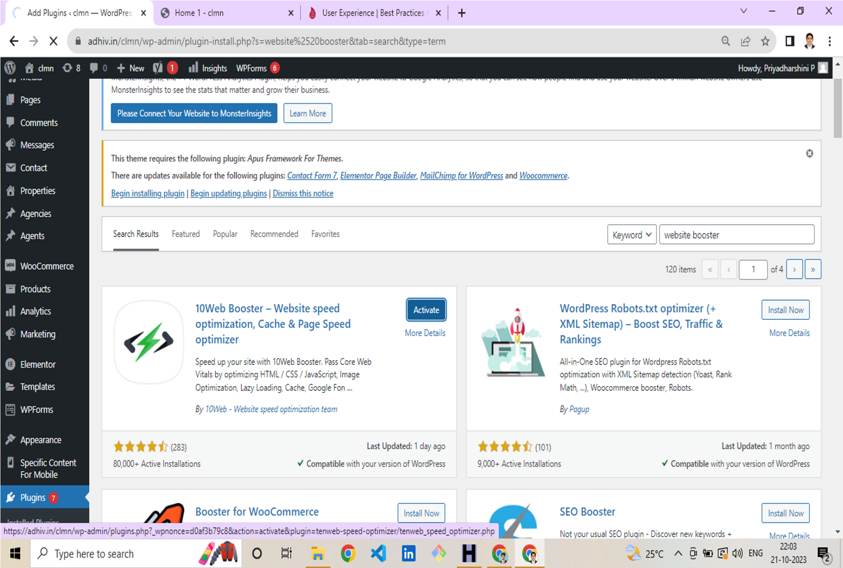

|  |  |
| --- | --- |
| NM ID | 02D944ABBB0B5B88A5245B7B35B7C006 |
| Project Name | How to Generate Traffic for your Website |

